Name: _______________________________________________
Foundation Unit 6 topic test
Date:
Time: 45 minutes
Total marks available: 39
Total marks achieved: ______

Questions
Q1.
The diagram shows a rectangle, a parallelogram and a triangle.
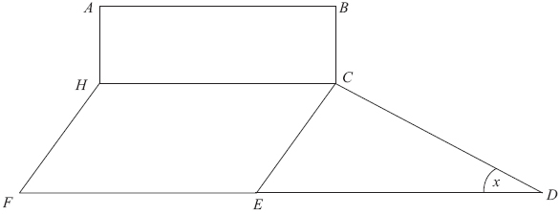
(a) Mark with arrows (>>) a pair of parallel lines.
(1)
(b) What type of angle is the angle marked x ?

. . . . . . . . . . . . . . . . . . . . . .
(1)
(c) Mark the angle HCE with the letter y.
(1)
(Total for Question is 3 marks)

Q2.
The diagram shows a trapezium and a square.
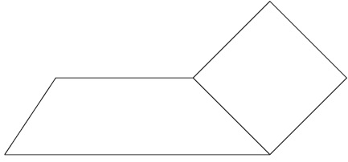
(a) Write down the size of each of the angles of a square.
........................................................... °
(1)
(b) Mark, with the letter O, an obtuse angle.
(1)
(c) Mark, with arrows (>>), a pair of parallel lines.
(1)
(Total for Question is 3 marks)
Q3.
An angle is marked below.
(i) What type of angle is it?
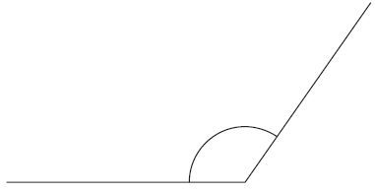
...........................................................
(ii) Measure the size of the angle.
...........................................................°
(Total for question = 2 marks)

Q4.
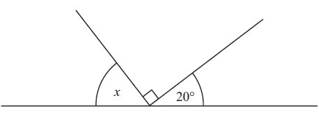 Diagram NOT accurately drawn
(i) Work out the size of the angle marked x.

. . . . . . . . . . . . . . . . . . . . . .°
(ii) Give a reason for your answer.
..............................................................................................................................................
(Total for Question is 2 marks)

Q5.
Here is an angle.
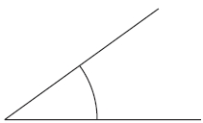
(a) Write down the mathematical name for this angle.
...........................................................
(1)
(b) Write down the size of the angle marked x.
...........................................................°
(1)
(Total for Question is 2 marks)

Q6.
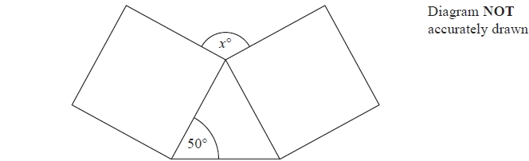
The diagram shows two identical squares and a triangle.
Find the size of the angle marked x°.
........................................................... °

(Total for question = 4 marks)

Q7.
*
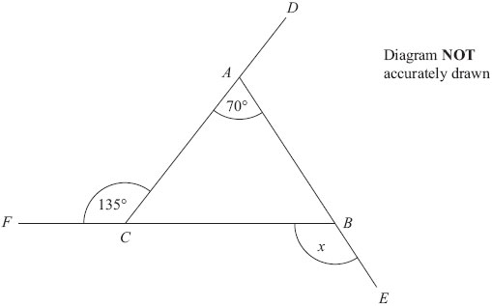
DAC, FCB and ABE are straight lines.
Work out the size of the angle marked x.
You must give reasons for your answer.

(Total for Question is 5 marks)

Q8.
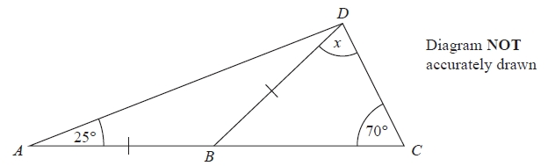
ABC is a straight line.
AB = BD
Angle BAD = 25°
Angle BCD = 70°
Work out the size of the angle marked x.
Give reasons for your answer.
(Total for Question is 4 marks)

Q9. *
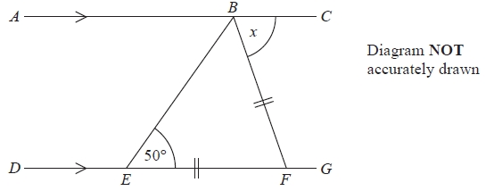
ABC is a straight line.
DEFG is a straight line.
AC is parallel to DG.
EF = BF.
Angle BEF = 50°.
Work out the size of the angle marked x.
Give reasons for your answer.
...........................................................°
(Total for Question is 4 marks)

Q10. *
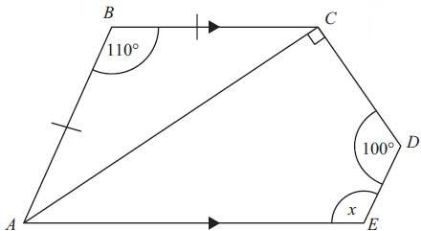 Diagram NOT accurately drawn
ABC is an isosceles triangle.
AB = BC.
Angle ABC = 110°.
ACDE is a quadrilateral.
Angle CDE = 100°.
Angle ACD is a right-angle.
AE is parallel to BC.
Work out the size of the angle marked x.
Give reasons for each stage of your working.

(Total for Question is 4 marks)

Q11.
The diagram shows three sides of a regular polygon.
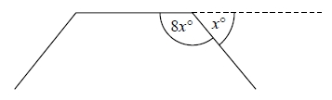
The size of each exterior angle of the regular polygon is x°.
The size of each interior angle of the regular polygon is 8x°.
Work out the number of sides the regular polygon has.

(Total for question = 3 marks)

Q12.
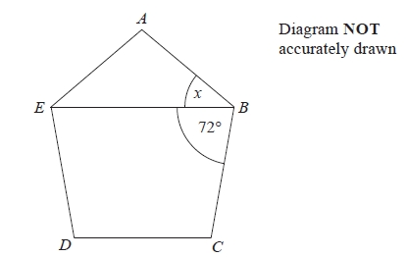
ABCDE is a regular polygon.
EB is a straight line.
Angle EBC = 72°.
Work out the size of the angle marked x.
........................................................... °

(Total for question = 3 marks)

Examiner's Report
Q1.
This question was well answered. In parts (a) & (c) some answers were spoilt with multiple lines and angles being indicated, but this was not common.

Q2.
This was an accessible question for most candidates. It allowed candidates a positive start to the paper. Some pupils tried to show all sets of parallel lines but generally approached the question in a sensible manner.

Q3.
Most students identified the angle in part (i) as being obtuse. Not surprisingly, the most common incorrect answer was 'acute'. Part (ii) was also answered very well. A small number of students read their protractor incorrectly and gave an answer in the range 53° to 57°. The answers given suggested that almost all the students had a protractor.

Q4.
A straightforward question but 36% of candidates did not score any marks and then only 30% were able to write down that the angles in a straight line add up to 180°

Q5.
This question was well attempted with few blank responses and most students gained all three marks. Common incorrect responses in part (a) were obtuse and right-angle, in part (b) the only repeated errors were 100 or 360 − 100 = 260

Q6.
A good proportion of students were able to find the size of the angle marked x°. Some students gave the other base angle of the triangle as 50° and worked out the third angle as 80° but then got no further. Some, however, wrongly assumed that the two unknown angles in the triangle were equal. It was good to see angles marked on the diagram but the working of some students was not presented particularly well and was sometimes difficult to follow.

Q7.
This question had a mixed response. The most popular approach was to calculate the internal angles of the triangle.
A significant number of candidates thought that the triangle was isosceles (some thought that it was equilateral). A common incorrect approach here was to either calculate the angle ACB correctly as 45 degrees and then state the angle ABC as 45 degrees or to calculate both the angles ACB and ABC (ie the 'base angles') as 55 degrees.
Few candidates were able to state the reasons for their calculations correctly, often omitting to use the word angle, eg 'the triangle is 180 degrees'.
Candidates should be advised to state the reasons for their calculations with the calculation, not at the end when it is unclear which calculation is being justified by the reason.
Most candidates were able to identify their calculations clearly with the angles by simply labelling the diagram, but candidates not using this approach should be advised to use a suitable unambiguous notation, eg labelling the internal angles a and b, to identify the angles. Most candidates gave their final answer in the form x = …

Q8.
Only a few fully correct answers were seen because reasons, containing all the key elements, were rare. When reasons were given they were seldom all given. If attempted, angles in a triangle add up to 180° and angles on a straight line add up to 180° were generally correct, however 'isosceles triangle equal to 25 since 2 parallel sides' was the most common quote for the rarely mentioned isosceles triangle.
A common method used was to start with the large triangle to give 25+70=95 then 180-95=85 unfortunately they then said x=85 so no marks could be awarded.
It was rare to see "angle ADB=25" written down but 25 was seen labelled in the diagram and this received 1 mark.

Q9.
This question was well attempted with few blank responses seen but many students failed to gain full marks. Those that did correctly identify angles on the diagram which led to x = 80° were on the whole unable to list all the appropriate reasons using correct words. Many students were still incorrectly referring to alternate angles as Z angles, some described a method and others missed key words out of their reasons, the most common of which was the word 'angles'. Weaker students where often able to identify at least one correct angle on the diagram, usually ABE = 50°, but then incorrectly labelled EFB = 50° or incorrectly labelled EAF and EFB as 65°. Those that used the diagram were more successful as it was often difficult to identify which angles students were finding from their working out alone.

Q10.
A surprising number of candidates (9%) scored one mark in this question, either for correctly calculating the missing angles in the isosceles triangle ABC or for finding the alternate angle CAE. Two marks were obtained for obtaining both angles and this was achieved by 4% of candidates. The 10% of candidates that found the missing angle x scored 3 marks but only 0.6% of candidates could state the reasons correctly. Few candidates use the three letter notation to identify angles. Some candidates used Z angles in their explanation which is no longer acceptable for alternate angles.

Q11.
No Examiner's Report available for this question

Q12.
This question was well attempted by most students, but more often than not, they did not achieve full marks. Common incorrect responses were from students who did not realise that it was necessary to calculate the interior or exterior angle of the pentagon in order to calculate the value of x. Other common incorrect responses included, assuming all angles in the quadrilateral, BCDE, were equal to 72 or that all the angles in the triangle, ABE, were equal to 60. Some students simply did 72÷2 which does lead to the correct answer but is clearly an incorrect and incomplete method and gained no marks. Another common incorrect response which gained 1 mark was where students correctly the found the interior angle of a pentagon then incorrectly did 108÷2 =54.

Mark Scheme
Q1.
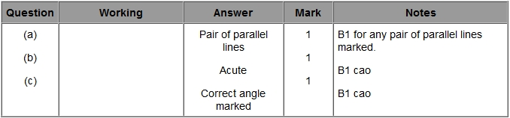

Q2.
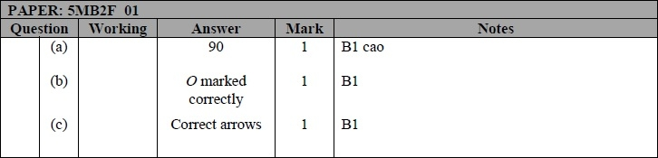

Q3.
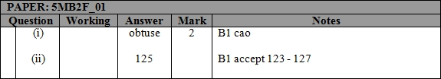

Q4.
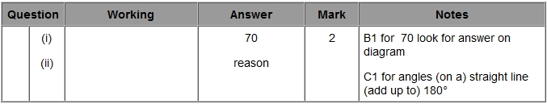

Q5. (a) and (c) only)
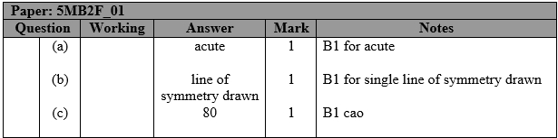

Q6.
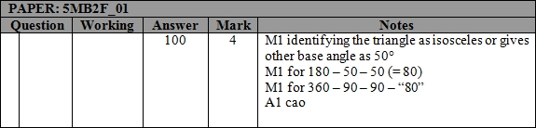

Q7.
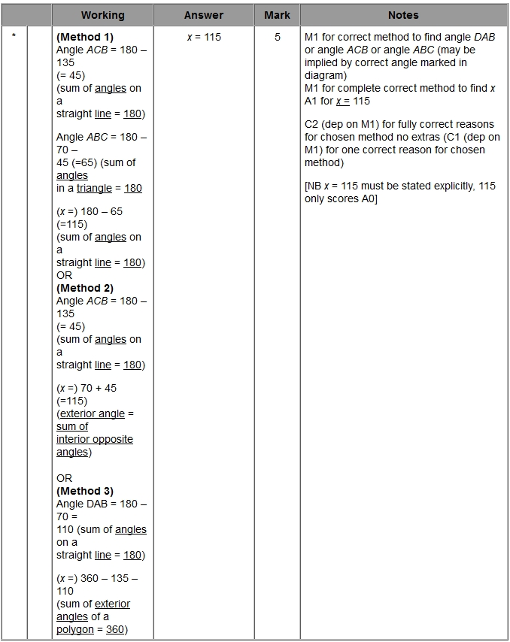

Q8.
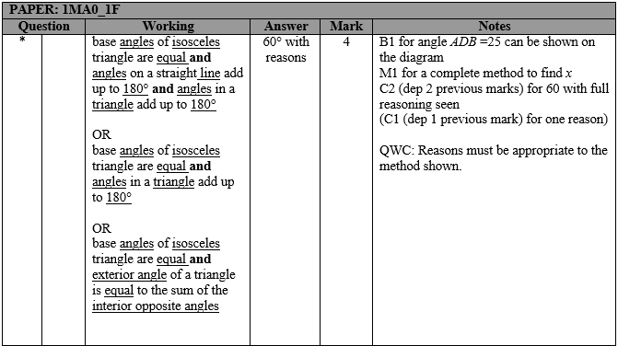

Q9.
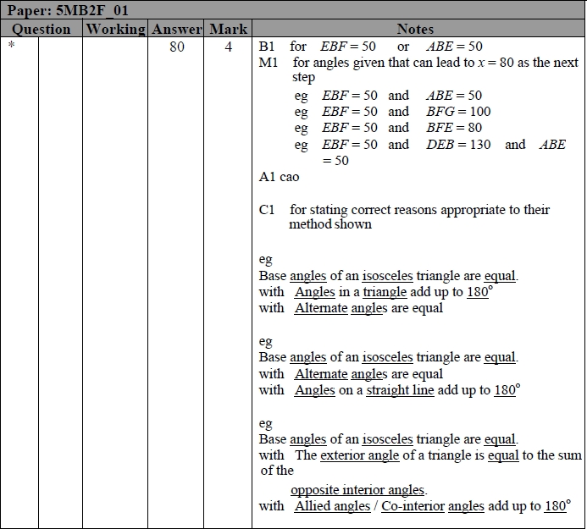

Q10.
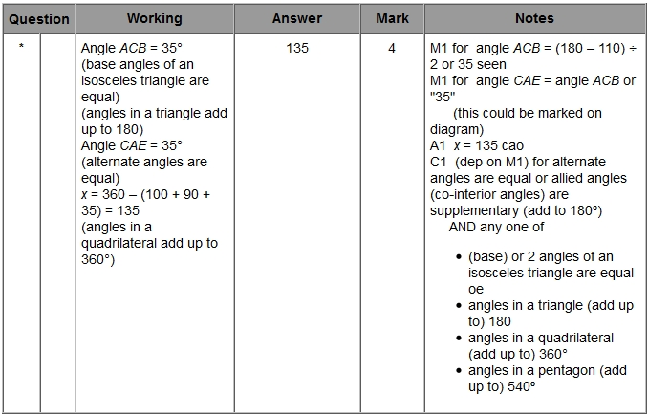

Q11.
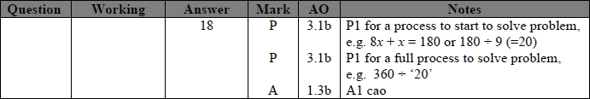

Q12.
